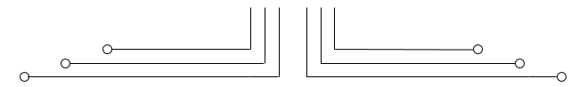

**1 D4 - TEKKOM B**



**Tugas**



Nama : Septian Bagus Jumantoro

Kelas : 1 – D4 Teknik Komputer B

NRP : 3221600039

Dosen : Dr Bima Sena Bayu Dewantara S.ST, MT.

Mata Kuliah : Praktikum Pemrograman Dasar 2

Hari/Tgl. Praktikum : Rabu, 09 Maret 2022

**Source Code**

#include <iostream>

using namespace std;

int main() {

    system("cls");

   int a[10][10], transpose[10][10], row, column, i, j;

   cout << "masukkan baris dan kolom matrix: ";

   cin >> row >> column;

   cout << "\nMasukkan element matrix: " << endl;

   for (int i = 0; i < row; ++i) {

      for (int j = 0; j < column; ++j) {

         cout << "element=" << i + 1 << j + 1 << ": ";

         cin >> a[i][j];

      }

   }

   cout << "\nMasukkan Matrix: " << endl;

   for (int i = 0; i < row; ++i) {

      for (int j = 0; j < column; ++j) {

         cout << " " << a[i][j];

         if (j == column - 1)

            cout << endl << endl;

      }

   }

   for (int i = 0; i < row; ++i)

      for (int j = 0; j < column; ++j) {

         transpose[j][i] = a[i][j];

      }

   cout << "\nTranspose matrix: " << endl;

   for (int i = 0; i < column; ++i)

      for (int j = 0; j < row; ++j) {

         cout << " " << transpose[i][j];

         if (j == row - 1)

            cout << endl << endl;

      }

   return 0;

}

**Output**

